Curriculum Vitae (CV)
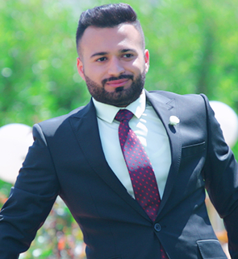
Objective:
Dear Mrs or Mr. I would like to work and get more life experience and offer my best such as skills that I have. I completed a placement in Schlumberger oil Service Company last summer, which I found it very useful. However, after graduation I want to gain further experience in Oil company so that I am fully prepared for Petroleum career and industry.
I have enclosed my CV which I hope will be of interest to you. I look forward to hearing from you in the near future if you feel you are able to offer me a placement.
Yours sincerely.
Personal information:
Name: Bashar Saadi Muhammad
Date of Birth: January / 1 / 1992
Nationality: Iraqi-Kurdish
Gender: Male-single
Address: Khabat ,Hawler , Iraq
Social status: Easy-going, adaptable and fast learner

Education: Petrol engineer graduated at Knowledge University
In 31/6/2017.
My research about HSE in KarGroup Refinary

Contact information:
Cell Phone No.: +964 (0) 750 492 37 88
+964(0)750 880 6181
Email Addresses: Basharkurdish46@gmail.com
Skype : Bashar.kurdish20101

Languages Skill:

Speaking | Writing | Reading | Language(s)
Perfect | Perfect | Perfect | Kurdish(mother tongue)
excellent | excellent | excellent | Arabic
Very Good | Very Good | Very Good | English

Jobs and Experience:
1. I have trained at Schlumberger oil Service Company
2. I have worked as a driver and interpreter with WIDE HOUSE GROUP.
3. I worked in Abo shahab city restaurant in VIP's department as assistant of manager.
4- I have worked as a driver and interpreter with ISLAND FALCON.
5- I have worked in Z.D.D decoration design engineering company
6- I have worked Taxi driver
Qualification:
1. I have pre- intermediate certification at Cambridge University
2. Salesman.
3. Security.
4- I have driver license
5- I have got my own car
Computer Skills:
- Microsoft Office Applications:
    - Microsoft Word
    - Microsoft Excel
    - Microsoft Access
    - Microsoft PowerPoint
    - Petrel 2009 (reservoir modeling software)
    - Introduction of AutoCAD software

Interests and Hobbies:
1- Researching related to my major.
2- Partying and hanging out.
3- Participating in socializing activities.

